**Biomarkers for Alzheimer’s Disease : Review**

German neurologist Alois Alzheimerin first described Alzheimer’s Disease (AD) in 1907 (Feng et al, 2014). AD is the most common cause for dementia, accounting for 70% of cases. The characteristics of the ultimately fatal neurodegenerative disease are progressive memory impairment, cognitive dysfunction, personality changes, language barriers, and other neuropsychiatric symptoms (Feng et al, 2014). Age is a huge factor in getting the disease. It is estimated that there is an 11% dementia risk at the age of 65, which increases steadily to 50% at the age of 80 (Fagan, 2014). Since age is such a strong risk factor, there has been a dramatic increase in the number of dementia cases because the average life expectancy continues to go up. Currently 5.2 million people in the United States (US) and 35 million people worldwide have AD. Projecting to 2050, an estimated 13.8 million people in the US and +75 million people worldwide will have AD. Since the disease is debilitating in the final stages there is a high cost of care. The 2013 annual cost of care in the US was more than $200 billion and projections surpassing $1 trillion annually by the year 2050 (Fagan, 2014). As AD progresses and severely reduces the quality of life for elderly people there becomes a personal, societal, and financial burden associated with the disease. As these burdens increase so does the demand to find effective treatments.

The pathogenesis of AD is very complex. A variety of factors have been found to be involved in AD, such as cholinergic nerve abnormalities, metabolic disorders, free radicals and apoptosis, excitatory amino acid toxicity and genetic background. Despite their multifactorial etiopathogenesis, genetics plays a primary role in the progression of disease (Gu et al, 2014). At present, there is no definitive diagnostic test or therapy to halt the progression or delay of its onset of AD (Satoh et al, 2014). Developing an intervening treatment that delays the onset of dementia by 5 years will result in an estimated 57% reduction in the number of affected patients and almost 50% reduction in projected Medicare costs (Fagan, 2014).

Researching biomarkers will improve the early diagnosis and identification of the disease. Biomarkers are defined as objective measures of a biological or pathogenic process that can be used to evaluate disease risk or prognosis, to guide clinical diagnosis, or to monitor therapeutic interventions (Fagan, 2014). Biomarker sensitivity and specificity are both important in diagnosis. A high sensitivity is required to minimize false negatives and high specificity is necessary for diagnostic accuracy and exclude symptomatic or prodromal cases that are not related to AD (Fagan, 2014). However, what is considered “high” differs depending on the purpose in which the biomarker is used whether treatment or diagnosis. Biomarkers can be found by analyzing either brain tissue, cerebrospinal fluid, or blood.

First, let’s discuss cerebrospinal fluid (CSF). It is an optimal source for biomarkers because it is in direct contact with the extra-cellular brain space and reflects the biochemical changes that are happening. Neuropathological characteristics of AD is the presence of extracellular amyloid plaques composed primarily of the aggregated amyloid-β (Aβ) peptide and intracellular neurofibrillary tangles (NFT) composed mainly of hyperphosphorylated tau (ptau), a microtubule-associated protein found predominantly in neurons (Cruchaga et al, 2013). CSF Aβ and tau levels have become definitive biomarkers for AD. If the levels of CSF ptau increase it corresponds with neuronal loss and cognitive decline.

One source of the varying levels of ptau and Aβ is genetic variants. These genes may be linked to autosomal dominant or familial early onset AD (Gu et al, 2014). There are four genes: amyloid precursor protein (APP), presenilin 1 (PS1), presenilin 2 (PS2) and apolipoprotein E (ApoE). A genome-wide association study (GWAS) detected four genetic loci associated with CSF levels. The first genetic locus that is associated with CSF tau and Aβ, and has a risk for AD is ApoE. The second is newly discovered and is at 3q28. This loci is the top hit for CSF tau and is associated with AD risk, tangle pathology, and global decline. The third locus is at 6q21.1, which is located in the TREM gene cluster near TREM2 (Cruchaga et al, 2013). This gene has rare variants recently reported substantial increase in the risk of AD. The last locus identified in this study did not show association with risk for disease, tangle pathology or memory decline.

ApoE plays an essential role in the delivery of fat, cholesterol, and antioxidants from the liver to all the cells of the body (Lin et al, 2013). The cholesterol deficiency in neurons may be caused by the advanced glycation end products in plasma proteins that are damaged in AD. A cascading response leads to impaired glutamate signaling, increased oxidative damage, mitochondrial and lysosomal dysfunction, increased risk of microbial infection, and ultimately apoptosis (Lin et al, 2013). Simple dietary modification could likely be a protective measure against AD.

TREM2 is expressed throughout the central nervous system and has high concentrations in white matter. It acts as a gateway for controlling microglial responses. When TREM2’s function is compromised it is likely to have ramifications on the clearance of cell debris and possibly the removal of beta amyloid (Guerreiro et al, 2013). This fuels an inflammatory cascade, which leads to systemic inflammatory response and incidental death of neurons.

There was a study that focused directly on the TREM2 (triggering receptor expressed on myeloid cells 2 protein) genetic variant. This study used genome, exome, and Sanger sequencing to analyze the genetic variability in TREM2. It was found that there were significantly more variants in exon 2 of TREM2 when comparing AD patients to normal controls. The seven main variants were R47H, H157Y, R98W, D87N, T66M, Y38C, and Q33X. D87 and R47H are associated with AD, T66M, Y38C, and Q33X were associated with frontotemporal dementia (Guerreiro et al, 2013).

Besides cerebrospinal fluid, blood is another way to check for biomarkers. Among the various technologies in the scientific field, microarray is a powerful and convenient tool to find biomarkers. Microarray technology is a tool to assess the expression levels of thousands of genes simultaneously (Hu et al, 2015). The goal is to obtain possible molecular clues regarding the underlying mechanisms of AD pathophysiology. Peripheral blood mononuclear cells were taken from patients that had AD and the expression levels were analyzed using microarray. The expression profiles were extracted from the Gene Expression Omnibus (GEO), GSE18309, and compared with the Affymetrix Human Genome platform GPL570. There were 60 gene expression levels that were altered in AD patients when compared to normal controls (NC).

A functional enrichment analysis was then performed on the DEGs using FuncAssociate with Gene Ontology (GO) attributes. The functional enrichment showed a dysregulation in response to nutrient, muscle contraction and cellular homeostasis. Response to nutrients (GO: 0007584) was the most significantly dysregulated, which can lead to the suggestion that nutrient supply, is related to AD. There are four genes associated Interleukin 6 signal transducer (IL6ST), Cyclin-dependent kinase inhibitor 2D (CDKN2D), Cholecystokinin A receptor (CCKAR), Microtubule-associated protein 1 B (MAP1B). IL6ST is a signal transducer shared by many cytokines, like IL6. MAP1B is involved in microtubule assembly, which is essential in neurogenesis. It has also been detected in sites of neurofibrillary degeneration (Gu et al, 2014). CCKAR is associated with this particular nutrient pathway. It encodes a G-protein-coupled receptor that binds non-sulfated members of the CCK family of peptide hormones.

CCKAR is widely distributed in the CNS and plays an important role in CNS function by interacting with dopamine and neurotransmitters. Since CCKAR is abundant in the CNS it is consistent with the various functions like regulation of satiety, learning and memory, analgesia, and neuropsychiatric disorders (Lin et al, 2013). When CCKAR is downregulated there is a dysfunction of the dopaminergic system, which contributes to the decline in cognitive functioning. It is found that CCKAR is significantly downregulated in AD and is closely related to both the response to nutrients and neuroactive ligand-receptor interaction. The most common pathway associated with DEGs is the neuroactive ligand-receptor interaction pathway. It is significantly dysfunctional in AD. Two DEGs (OPRM1 and OPRD1) in the opioid receptor family were enriched. Opioid receptors help with regulation of neurotransmitters and play a role in the pathogenesis of AD.

Besides cerebrospinal fluid and blood, brain tissue is another way to check for biomarkers. There are altered gene expressions in the hippocampus that if identified can provide diagnostic factors and therapeutic targets for AD. The hippocampal CA1 pyramidial neurons are particularly vulnerable to neurdegeneration and bear NFTS during the early stages of AD (Hu et al, 2015). The underlying mechanism of degeneration is still unknown. Performing a GO enrichment analysis separated DEGs into three categories: Biological processes, cellular components, and molecular function. Of these three categories there were 2 significant genes in each. Biological processes shows genes associated with respiratory electron transport chain (GO: 0022904) and gluconeogenesis (GO: 0006094) are significantly enriched. Cellular components shows genes associated with the cytoplasm (GO:0005737) and mitochondrion (GO: 0005739) are significantly enriched. Molecular function shows genes related to protein binding (GO:0005515) and nucleotide binding (GO: 0000166) are significantly enriched [Figure 1] (Hu et al, 2015).

According to functional similarity clustering, the DEGs were clustered into 5 functions including protein transport, RNA splicing, intracellular protein transport, regulation of cell motion, and protein complex assembly (Zhao, 2015). Bai et al showed that liquid chromatography-tandem mass spectrometry (LC-MS/MS) was used and reveal an enrichment of U1snRNP (small nuclear ribonucleoprotein) in AD. U1snRNP is a constituent of the spliceosome complex responsible for RNA processing and were found accumulated in neural cell bodies with AD. The functional consequence is reflected in widespread alterations in RNA processing, which plays a key role in AD pathogenesis (Bai et al, 2013).

The three different sources for biomarkers have allowed a variety of possible drug targets to focus therapeutic treatments. There is also a new, non-invasive, cheap biomarker called Electroencephalography (EEG) that is not yet considered accurate enough for clinical practice. There are multiple EEG biomarkers related to activity in the beta-frequency range (13-30Hz) that can’t show conversion from Mild Cognitive Impairment (MCI) to AD (Poil, 2013). It has a sensitivity of 88% and specificity of 82%. It is not suggested to base therapies off EEG biomarkers, but in combination to other biomarkers it could be helpful and potentially reliable.

Despite the optimism that arises with biomarkers, there are some challenges. Biomarkers must have maximized sensitivity and reliability. There are usually variations between laboratories and marker levels. There are worldwide efforts to commercialize assay platforms with automated, high-throughput capabilities to create standardization (Fagan, 2014). Also, depending on the medium chosen for the biomarker because CSF requires a lumbar puncture and is more invasive than a simple blood draw and brain tissue is obtained post mortem.

Researchers are getting close to standardizing biomarkers. It is well known that aggregated Aβ peptide and intracellular neurofibrillary tangles composed mainly of ptau are markers for Alzheimer’s Disease**.** The four main genes associated are: amyloid precursor protein (APP), presenilin 1 (PS1), presenilin 2 (PS2) and apolipoprotein E (ApoE). The dysregulation of response to nutrient, muscle contraction and cellular homeostasis makes AD a complicated neurodegenerative disease. With more funding being spent on definitive diagnostic tests and therapy to halt the progression or delay the onset of AD, we have identified where and what we should focus research on. Every publication is one step close to finding an answer and improving the quality of life for millions.

**Figures**

Figure 1:

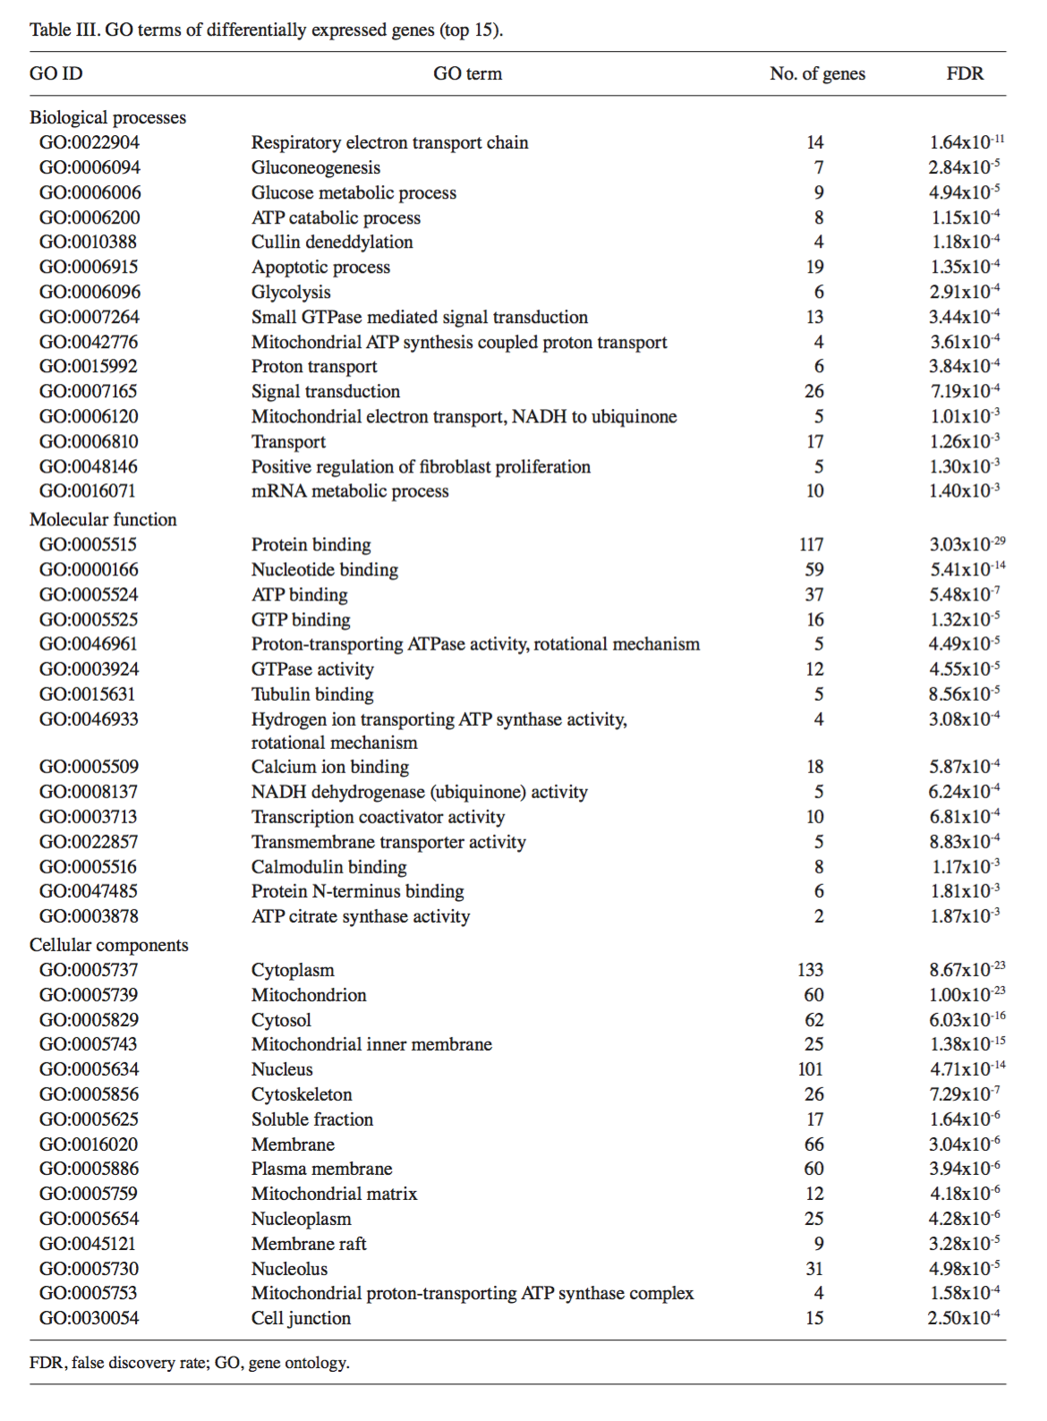

(Hu et al, 2015)

**References**

Bai, Bing, Chadwick Hales, Ping-Chung Chen, Yair Goal, et al. "U1 Small Nuclear Ribonucleoprotein Complex and RNA Splicing Alterations in Alzheimer’s Disease." *Proceedings of the National Academy of Sciences* 110.41 (2013): 16562-6567. Print.

Cruchaga, Carlos, John S.K. Kauwe, Oscar Harari, Sheng Chih Jin, et al. "GWAS of Cerebrospinal Fluid Tau Levels Identifies Risk Variants for Alzheimer’s Disease." *Neuron* 78 (2013): 256-68. Print.

Fagan, Anne M. "CSF Biomarkers of Alzheimer’s Disease: Impact on Disease Concept, Diagnosis, and Clinical Trial Design." *Advances in Geriatrics* 2014 (2014): 1-14. Print.

Fargo, Keith, and Laura Bleiler. "2014 Alzheimer’s Disease Facts and Figures." *Alzheimer’s & Dementia* 10 (2014): E47-92. Print.

Feng, Bo, Peng Hu, Jinbo Chen, Qingxin Liu, Xizhi Li, and Yifeng Du. "Analysis of Differentially Expressed Genes Associated With Alzheimer’s Disease Based on Bioinformatics Methods." *American Journal of Alzheimer’s Disease & Other Dementias* (2014): 1-6. Print.

Gu, Chao, and Ting Shen. "CDNA Microarray and Bioinformatic Analysis for the Identi Cation of Key Genes in Alzheimer's Disease." *INTERNATIONAL JOURNAL OF MOLECULAR MEDICINE* 33 (2014): 457-61. Print.

Guerreiro, Rita, Aleksandra Wojtas, Minerva Crrasquillo, Ekaterina Rogaeva, et al. "TREM2 Variants in Alzheimer’s Disease." *The New England Journal of Medicine* 368.3 (2013): 117-27. Print.

Hu, Wanhua, Xiaodong Lin, and Kelong Chen. "Integrated Analysis of Differential Gene Expression Pro Les in Hippocampi to Identify Candidate Genes Involved in Alzheimer's Disease." *Molecular Medicine Reports* 12 (2015): 6679-687. Print.

Ling, Hang, Tao Zhang, Yuxian Wu, Yunxia Wang, Weiwen Wang, and Qingsong Wang. "Related Genes and Potential Biomarkers for Early Diagnosis of Alzheimer’s Disease: A Preliminary Study Based on DNA Microarray." *American Journal of Alzheimer’s Disease & Other Dementias* 0 (2013): 1-6. Print.

Poil, Simon-Shlomo, Willem De Haan, Wiesje M. Van Der Flier, Huibert D. Mansvelder, Phillip Scheltens, and Klaus Linkenkaer-Hansen. "Integrative EEG Biomarkers Predict Progression to Alzheimer’s Disease at the MCI Stage." *Frontiers in Aging Neuroscience* 5 (2013): 1-12. Print.

Satoh, Jun-ichi, Yoji Yamamoto, Naohiro Asahina, Shouta Kitano, and Yoshihiro Kino. "RNA-Seq Data Mining: Downregulation of NeuroD6 Serves as a Possible Biomarker for Alzheimer’s Disease Brains." *Disease Markers* 2014 (2014): 1-10. Print.

Zhao, Yanxin, Wei Tan, Wenhua Sheng, and Xiaohong Li. "Identification of Biomarkers Associated With Alzheimer’s Disease by Bioinformatics Analysis." *American Journal of Alzheimer’s Disease & Other Dementias* (2015): 1-6. Print.